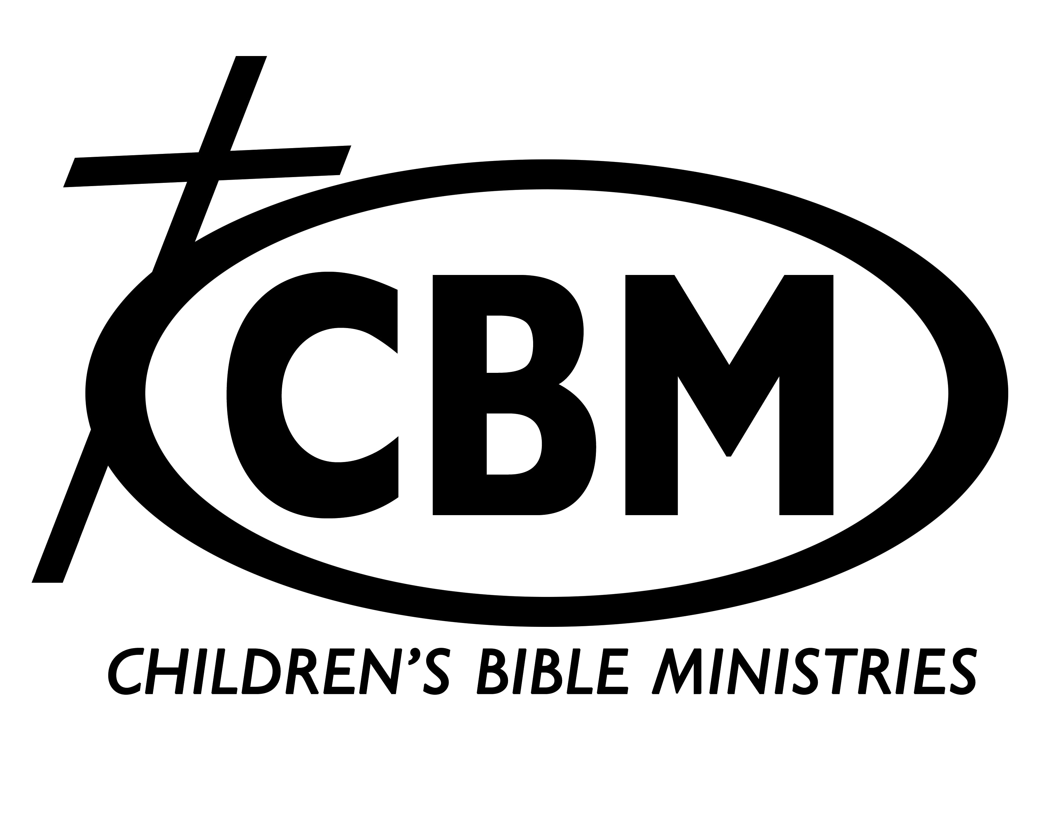
CHILDREN’S BIBLE MINISTRIES OF MD, INC.
1600-B Emory Road Upperco, MD 21155 (410) 796-7990
E-Mail: cbmofmd@aol.com Web Site: www.cbmmd.org
Area Director: Denise Morgan Office Manager: Lois Jones

SUMMER MISSIONARY INTERN APPLICATION

Please fill out this questionnaire completely and legibly. You may use extra paper to elaborate on any questions. Put your name on each additional sheet of paper and mail packet to the above address. No applications will be accepted after FEBRUARY 15th. (***Please see bottom of page two for list of things to be returned with this application packet.***)

Name _____________________________________ E-Mail _______________________________

Phone Home: Cell:________________________

Address______________________________________________________________________________
Street City State Zip

Social Security Number___________________________________ Birthdate_______________________

BACKGROUND AND EXPERIENCE
- On a separate sheet of paper: Give a brief account of your conversion; state on what you base your salvation; tell why you want to take part in the Summer Missionary Intern Program; list any experience you have in leading others to Christ; Christian service; and history ministering to children.
2. Church affiliation _________________________________ Church Phone ( ) _____________
Pastor’s Name and full (including state and zip code) mailing Address ___________________
____________________________________________________________________________
3. Are you willing to keep any special denominational doctrines out of CBM teaching? ____________________________________________________________________
4. Can you sign the enclosed statement of faith without reservation? _______________________
5. Do you believe that one can be assured of his salvation? _______________________________

EDUCATIONAL INFORMATION:
1. Highest grade completed by 6/20th__________ Grade average in school this year ____________
2. Extracurricular activities (clubs, band, sports, etc.) ___________________________________
_______________________________________________________________________________

PERSONAL REFERENCES:
Please give the name and address of two adults who know you well. (Not relatives or your pastor.)

Name ______________________________________________________ Phone ___________________

Address _____________________________________________________________________________
Street City State Zip

Name_______________________________________________________Phone____________________

Address______________________________________________________________________________
Street City State Zip

PLEASE ANSWER THE FOLLOWING QUESTIONS:
1. I understand that, to be accepted, I must attend Saturday evangelism workshop plus 1week of training. _______
- I understand that my final acceptance depends on my deportment, zeal, ability, teachability, and cooperation displayed during the training period. ________________
- In order to be spiritually equipped as a Summer Missionary Intern, you need to be consistent in having daily time with God. Are you? ____________ If not, will you begin now? ________
- Do you have a driver’s license? __________ If not, will you have one by June 15? _________ Do you own a car? __________ If yes, are you planning to bring your car with you to the training retreat? __________
- Do you understand reports are due the Monday after the week being reported on? _______
- Do you believe God has called you to this ministry? ________
- Do you belong to any secret society, party, or lodge? ________
- Do you use tobacco? __________ Alcohol? __________ Drugs? __________
- Were you ever dismissed from any school? __________ If yes, why? _________________
- Will you be consistently dependable to start work on time? __________
- Are you willing to work on a team with at least one other person? __________
- Have you had any previous training for children’s ministry? ___________ Where? _________
- Have you ever served in a summer missions program? _______ Where? __________________
- Do you agree to serve all 5 weeks of ministry? _______________
15. I understand my expenses and support will be raised by deputation. ______________

YOUR APPLICATION SHOULD BE TURNED IN WITHIN ONE WEEK OF RECEIVING IT.
PLEASE INCLUDE:
- The enclosed, carefully read and signed, CBM Statement of Faith.
- A separate sheet on which you have written your personal testimony.
- The enclosed health form. Parents of those under 18 must sign both forms.

- Please email a recent, clear, wallet-sized picture of yourself with a white or other background (that does not take away from your picture) to be used for a prayer card to Denise Morgan at cbmofmd@aol.com

Applicant’s Signature _____________________________________________ Date ____________

Parents or Guardian’s Signature (if under 18) ___________________________Date ____________

HEALTH RECORD

PLEASE FILL IN COMPLETELY:

Name _______________________________________Sex ______ Birth Date ______________

Address _____________________________________________ State ________ Zip _________

Phone ___________________________________________________ Blood type ___________

Do you have: (Check appropriate)
Heart trouble? _______ Lung trouble? _______ Skin trouble? _______ Hay Fever? _______
Hernia? _______ Asthma? _______ Diabetes? _______ Seizures? _______
Other (please explain) ___________________________________________________________
1. Were you ever seriously ill? __________ If so, what & when? ________________________
2. Have you been under medical care in the past 3 months? _________ If so, for what? _______
3. How is your health now? (circle one) good average poor
4. Do you have any food allergies? __________ Which foods? ___________________________
5. Date of last tetanus shot? _______________

GIVE AT LEAST TWO NAMES TO CONTACT IN CASE OF EMERGENCY (***At least one must be from outside of your immediate family.***):

Name _________________________________________________ Phone _________________

Name _________________________________________________ Phone _________________

Name _________________________________________________ Phone _________________

In case of emergency, I understand every effort will be made to contact me. In the event I cannot be reached, I hereby give permission to the Director and Staff to secure necessary treatment from a physician or hospital for the well being of my son or daughter. I will not hold Children’s Bible Ministries or its paid or volunteer staff liable for sickness, injury or death should any of these things befall my son or daughter named herein.

Insurance Company ________________________________________ Policy # _____________

Signature of Parent or Guardian ________________________________ Date __________

Signature of Parent or Guardian ________________________________ Date __________

STATEMENT OF FAITH
In effect June 9, 2019
CHILDREN’S BIBLE MINISTRIES, INC. (Formerly Children’s Bible Mission)

Children’s Bible Ministries, Inc. serves along nondenominational lines, and as such there are certain essential truths which we believe. As Christians we believe in the necessity of the new birth as the work of God, the Holy Spirit to be obtained only by receiving the Lord Jesus Christ and that men are saved by grace through faith not by works.

- We believe the Scriptures of the Old and New Testament to be the verbally inspired (God-breathed) Word of God, the final authority for faith and life, inerrant in the original writings (Matt. 5:18; John 16:12-13; II Tim. 3:16-17; II Pet. 1:20-21).

- We believe in the deity of the Lord Jesus Christ as fully God and fully man, conceived by the Holy Spirit, born of a virgin; as God, co-equal and co-existent with God the Father and God the Holy Spirit (Matt. 1:1-2:13; John 1:1-11; 14:16; Phil. 2:5-11; Col. 1:15).

- We believe in man’s fallen condition. Through nature, choice and practice he is guilty before God and is righteously judged fit only for everlasting punishment (Gen. 3:1-13; Matt. 25:46; Rom. 3:10 & 23; 5:12-21; I Cor. 15: 21-22; II Thess. 1:7-10; Rev. 20:12-15).

- We believe Jesus Christ offered on our behalf the only acceptable sacrifice for sin and was raised in the same body from the dead according to the Scriptures. Christ has secured our redemption through the shedding of His blood, qualifying the saints for service here, a like resurrection, and a place in His divine presence for eternity (Matt. 28; Luke 24:39-43; Rom. 3:21-28; 5:10-11; I Cor.15: 3-4; I Tim. 2:5-6; Heb. 9:11-22; I Pet. 1:18-20; I John 2:2; 5:10-13).

- We believe that repentance, forgiveness and becoming a new creature are several of the many experiences of the Christian who is kept by God’s power, being secure in Christ forever and that it is the privilege of believers to rejoice in the assurance of salvation.
(John 6:37-40; 10:27-30; Rom. 8:1, 38-39; II Cor. 5:17; I John 5:11-13).

- We believe that God the Holy Spirit is a person who convicts sinners and who regenerates and baptizes them at the moment of their salvation into the body of Christ. We also believe that the Holy Spirit indwells and seals until Christ returns, all who believe, and fills and empowers for service those who are yielded to Him (John 16:8-11; Rom. 8-9; I Cor. 6:19-20; 12:12-14; Gal. 5:16; Eph. 1:13-14; 4:30; 5:18; Titus 3:5).

- We believe in the visible, personal and imminent return of the Lord and Savior Jesus Christ for His church (John 14:3; Acts 1:9-11; I Thess 4:13-18).
- We believe in the bodily resurrection of the saved and of the lost, the everlasting blessedness of the saved and the everlasting punishment of the lost (John 11:23-27; Rom.
8:11; II Cor. 5:1; I Thess. 4:13-18; Rev. 20:12-15).

- We believe that Christ made provision for all the effects of sin in the atonement and that God heals in answer to believing prayer according to His sovereign discretion. Healing may not be claimed on the same unconditional basis as salvation, and the final deliverance from sickness awaits the believer in glory (I Cor. 15:51-57; II Cor. 12:7-9; Phil. 3:20-21; I John 3:2).

- We believe that some gifts of the Holy Spirit are permanent and are intended for use throughout the entire Church age. Other gifts were temporary and were given in the apostolic age for the purpose of founding the church. These include the gifts of Apostleship, Prophecy, Miracles, Healings, Tongues, and the Interpretation of Tongues.
At the same time, we affirm that God performs miracles as He wills (John 14:16-17; John 16:7-15; Romans 8:9; 1 Corinthians 6:19; 1 Corinthians 12:13, 28-30; Ephesians 2:20-22; Ephesians 4:1-16, 30; Hebrews 2:1-4; Titus 3:5).

- We believe God sovereignly and immutably creates each person as a male or female. These two distinct, complementary genders together reflect the image and nature of God and His plan for man and woman (Gen. 1:27; Matt. 19:4).

- We believe in the biblical view of marriage as sanctioned and defined by God in His Word, which is the exclusive, covenantal union between one man (born biologically male) and one woman (born biologically female) (Gen. 2:18-24; Eph. 5:22-23; Matt. 19:4-6; Mark 10:6-9).

If you do not thoroughly agree with any of these statements, please state your reasons below or on a separate sheet of paper.

“If my position changes on any point of the Statement of Faith, I will notify the National Director immediately.”

CBM Area: Maryland Date: ________________________________________

Signed: __________________________________________________________________________________

