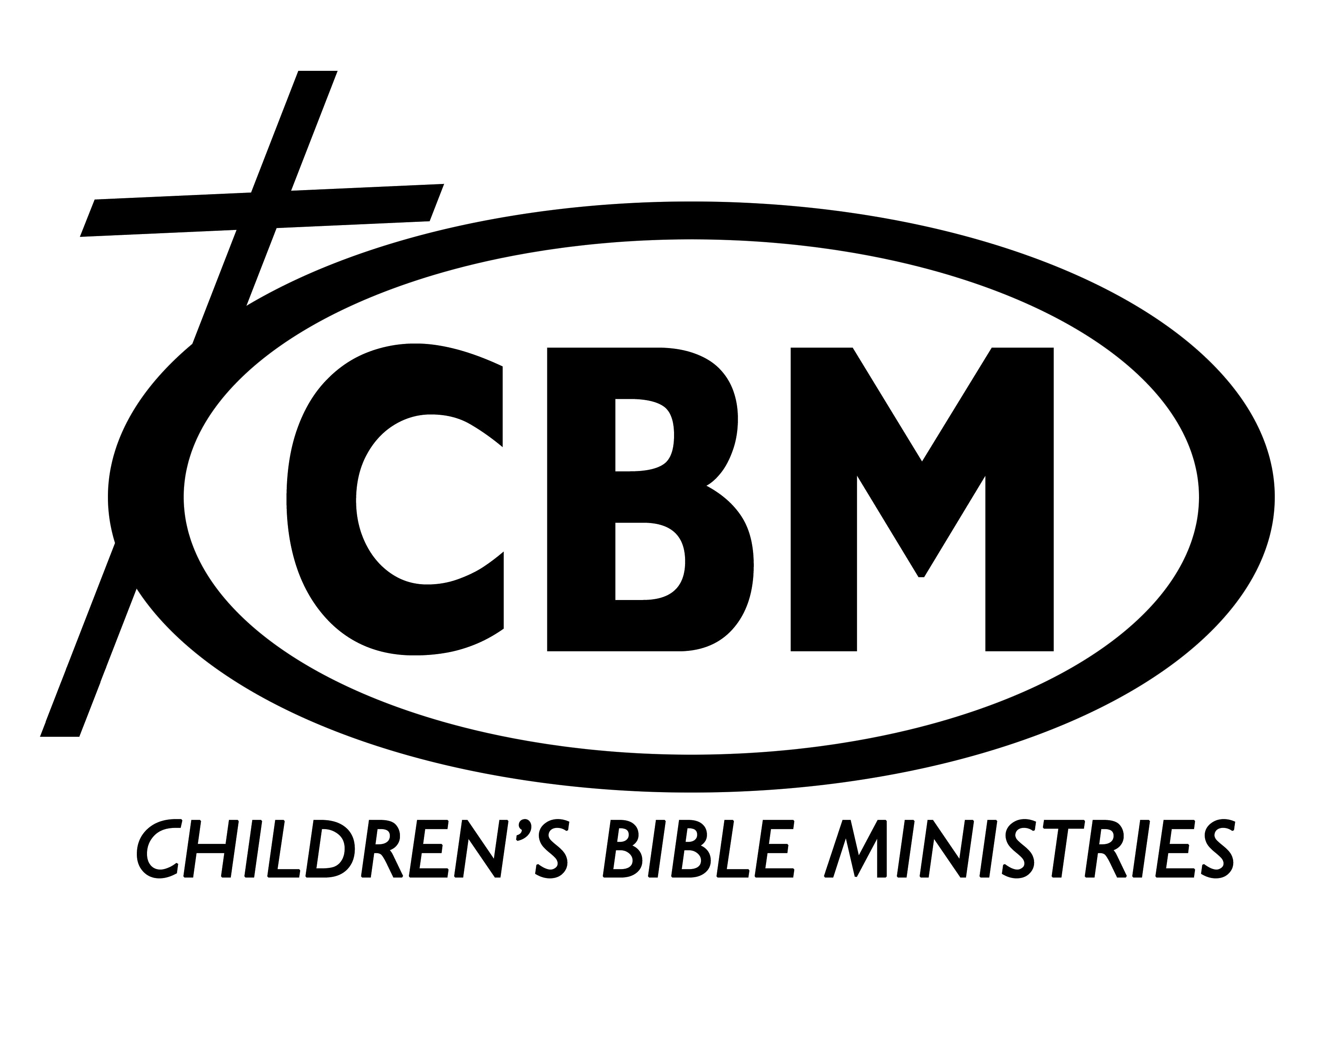
CHILDREN’S BIBLE MINISTRIES OF MARYLAND, INC.
1600-B Emory Road Upperco, Maryland 21155
(410) 796-7990 • cbmofmd@aol.com • www.cbmmd.org
GENERAL APPLICATION
Please turn in ALL sheets from this application SIGNED and COMPLETELY FILLED OUT. Applications must be mailed or submitted in person. Emailed applications will not be accepted. Please attach a resume that include educational background, professional & ministry experience. Please call office, if you have any questions. Thank you!

New Applicant _____ Returning____ Today’s Date_________

Name ______________________________________ Maiden or other name used ________________

Phone: Home: ________________ Cell: __________________ Email: _____________________

Address________________________________________________________________________

Street City State Zip

Birthdate_______/_______/_________Marital Status ___________Present Occupation____________

Area of Ministry Interested to serve __________________Date/time of Availability: ______________

Can you commit to a year: Yes___ No_____ or Maximum time commitment:___________________

Tell us briefly, when and how you became a Christian ___________________________________________________________________________

To what extent do you participate in your church activities? _________________________________________________________________________

Do you have Bible devotions? ________How often? _____________Are you certified in CPR___first aid___ Lifeguard? ____
Do you have any other special skills or talents? __________________________________________________________________________________
The following questions are required for those working with children. Use another sheet of paper if you need to elaborate on the answers.
Have you ever been charged with child abuse? _____ Have you ever been arrested? _____Have you ever been charged with a felony? _______ Have you ever used drugs? _______ Do you smoke/ use tobacco? _____Do you drink alcoholic beverages? _______ Do you have any health issues or limitations______________________________________________________________________
Christian Recommendations: Pastor or Assistant Pastor (whoever knows you best).
Name of person giving recommendation ________________________________________________

Church Name______________________________________ Church Phone____________________

Church Address_____________________________________________________________________ Street City State Zip

Please list two adult acquaintances or Professional references (NOT relatives) who know your spiritual walk.
Name ____________________________________________________ Phone ___________________

Address ___________________________________________________________________________
Street City State Zip

Name_____________________________________________________Phone____________________

Address____________________________________________________________________________ Street City State Zip

Applicant Signature ________________________________________ Date____________
Parent Signature (Applicant under 18) __________________________
How did you learn about CBM? From a friend_____ Newsletter_____ Website______

STATEMENT OF FAITH
CHILDREN’S BIBLE MINISTRIES, INC. serves along non-denominational lines, and as such there are certain essential truths which we believe. As Christians we believe in the necessity of the new birth as the work of God, the Holy Spirit to be obtained only by receiving the Lord Jesus Christ and that men are saved by grace through faith not by works.

- We believe the Scriptures of the Old and New testament to be the verbally inspired (God-breathed) Word of God, the final authority for faith and life, inerrant in the original writings (Matt. 5:18; John 16:12-13; II Tim. 3:16-17; II Pet. 1:20-21).
- We believe in the deity of the Lord Jesus Christ as fully God and fully man; as man, conceived by the Holy Spirit, born of a virgin; as God, co-equal and co-existent with God the Father and God the Holy Spirit (Matt. 1:1 – 2:13; John 1:1-11; 14:16; Phil. 2:5-11; Col. 1:15).
- We believe in man’s fallen condition. Through nature, choice and practice he is guilty before God and is righteously judged fit only for everlasting punishment (Gen. 3:1-13; Matt. 25:46; Rom. 3:10 & 23; 5:12-21; I Cor. 15:21-22; II Thess. 1:7-10; Rev. 20:12-15).
- We believe Jesus Christ offered on our behalf the only acceptable sacrifice for sin and was raised in the same body from the dead according to the Scriptures. Christ has secured our redemption through the shedding of His blood, qualifying the saints for service here, a like resurrection, and a place in His divine presence for eternity (Matt. 28; Luke 24:39-43; Rom. 3:21-28; 5:10-11; I Cor. 15:3-4; I Tim. 2:5-6; Heb. 9:11-22; I Pet. 1:18-20; I John 2:2; 5:10-13).
- We believe that repentance, forgiveness and becoming a new creature are several of the many experiences of the Christian who is kept by God’s power, being secure in Christ forever and that it is the privilege of believers to rejoice in the assurance of salvation. (John 6:37-40; 10:27-30; Rom. 8:1, 38-39; II Cor. 5:17; I John 5:11-13).
- We believe that God the Holy Spirit is a person who convicts sinners and who regenerates and baptizes them at the moment of their salvation into the body of Christ. We also believe that the Holy Spirit indwells and seals until Christ returns, all who believe, and fills and empowers for service those who are yielded to Him (John 16:8-11; Rom. 8:9; I Cor. 6:19-20; 12:12-14; Gal. 5:16; Eph. 1:13-14; 4:30; 5:18; Titus 3:5).
- We believe in the visible, personal and imminent return of the Lord and Savior Jesus Christ for His church (John 14:3; Acts 1:9-11; I Thess. 4:13-18).
- We believe in the bodily resurrection of the saved and of the lost, the everlasting blessedness of the saved and the everlasting punishment of the lost (John 11:23-27; Rom. 8:11; Ii Cor. 5:1; I Thess. 4:13-18; Rev. 20:12-15).
- We believe that Christ made provision for all the effects of sin in the atonement and that God heals in answer to believing prayer according to His sovereign discretion. Healing may not be claimed on the same unconditional basis as salvation, and the final deliverance from sickness awaits the believer in glory (I Cor. 15:51-57; II Cor. 12:7-9; Phil. 3:20-21; I John 3:2).
- We believe that the primary purpose for spiritual gifts as given by the Holy Spirit is for the edifying of the church and the propagation of the gospel of Christ. We believe that tongues, miracles and the raising of the dead, as evidenced in apostolic times, were to authenticate the giving of the new revelation, primarily to the Jewish nation at that time. These were never a sign of the baptism or filling of the Holy Spirit, nor are they to be pursed (I Cor.12:28-31; 13:8-10; Eph. 2:20; 4:7-12; Heb. 2:3-4).

Signature of Applicant:__________________________________________Date:__________________
AUTHORIZATION TO RELEASE INFORMATION FORM
I hereby AUTHORIZE and request any present or former employer, school, law enforcement agency, or other persons having personal knowledge about me, to furnish bearer with any and all information in their possession regarding me in connection with my employment in a critical position. I am willing that a photocopy of this authorization be accepted with the same authority as the original, an I specifically waive any written notice from any present or former employer who may provide information based upon this authorized request. I understand this AUTHORIZATION request. I understand this AUTHORIZATION is to be part of the written employment application that I sign. I understand that positions that are designated critical require background checks for the purpose of evaluating me for employment, promotion, reassignment, reclassification, transfer, or retention as an employee. I also understand that any misrepresentation; falsification or omission of facts herein may be grounds for disqualification, release or dismissal.
PRINT NAME: _______________________________________________________________
Last First Middle
DATE OF BIRTH: ____/_____/_______SOCIAL SECURITY #: ______-______-__________ HOME PHONE #: (_____)________-____________
OTHER NAMES YOU HAVE USED: _________________________________________________
Current Address: _____________________________________________________________________
Street Number & Name City State Zip
How long have you lived at your current address? __________Years If at current address less than 10 years, please complete information below for the past 10 years:
____________________________________________________________________How Long? ____
Street Number & Name City State Zip
____________________________________________________________________How Long? ____
Street Number & Name City State Zip
Have you ever been convicted of any crime involving a child or children? ________Have you ever been convicted of a crime other than minor traffic violations? ________
If you answered YES to either of the above questions, give details below:
CRIME CHARGED: ______________________________________________COURT: _____________________________ DISPOSITION OF CASE: _______________________
Have you ever been convicted of a crime under another name? ____________If YES, state name: ___________________________________________Complete driver’s License information only if you will be bringing your car to camp with you. DRIVER’S LICENSE INFORMATION
______________________________________________________
License number Expiration Date State of Issue
PRIVACY NOTICE
The state of Maryland requires that Children’s Bible Ministries of Maryland, Inc. provide the following information to individuals who are asked to supply information about themselves. The principal purpose for requesting the information on this form is to conduct background checks on individuals selected for critical positions. Children’s Bible Ministries of Maryland, Inc. policy and federal statute authorize the maintenance of this information. Furnishing all information requested on this form is mandatory. Failure to provide such information shall result in a determination that the applicant is ineligible for employment or not appropriate for reassignment. The official for maintaining the information contained on this form is the Human Resources Department for staff and student employment.
I hereby certify that all statements on this application are true and correct to the best of my knowledge and belief. I understand that the Children’s Bible Ministry of Maryland, Inc., solicits this information so as to be informed of my previous record and character. I understand that my employment with the Children’s Bible Ministry of Maryland, Inc. depends upon successful completion of a criminal background investigation. If employed, I understand that any falsification, misrepresentation or omission of facts of this record may be considered cause for release or dismissal.
APPLICANT SIGNATURE: _____________________________________ DATE: _________________________
HEALTH RECORD
PLEASE FILL IN COMPLETELY:

Name _______________________________________Sex ______ DOB ______________

Address _____________________________________________ State ________ Zip _________

Phone ___________________________________________________ Blood type ___________

Do you have: (Check Appropriate?)
Heart trouble? _______ Lung trouble? _______ Skin trouble? _______ Hay Fever? _______
Hernia? _______ Asthma? _______ Diabetes? _______ Seizures? _______
Other (please explain) ___________________________________________________________
1. Were you ever seriously ill? __________ If so, what & when? ________________________
2. Have you been under medical care in the past 3 months? _________ If so, for what? ______________
3. How is your health now? (circle one) good average poor
4. Do you have any food allergies? __________ which foods? ___________________________
5. Date of last tetanus shot? _______________

GIVE AT LEAST TWO NAMES TO CONTACT IN CASE OF EMERGENCY

Name ___________________________________Phone _________________Relationship_____________

Name ___________________________________Phone _________________Relationship_____________

In case of emergency, I understand every effort will be made to contact me. In the event I cannot be reached, I hereby give permission to the Director and Staff to secure necessary treatment from a physician or hospital for the wellbeing of my son or daughter. I will not hold Children’s Bible Ministries or it’s paid or volunteer staff liable for sickness, injury or death should any of these things befall my son or daughter named herein.

Insurance Company ________________________________________ Policy # _____________________

Signature of Applicant or Parent/Guardian (if applicant is under 18)

_______________________________________ Date ______________

Camp Worker Immunization Information
Are you exempt from any immunization on medical or religious grounds?
□YES, provide a signed copy of Maryland Department of Health and Mental Hygiene Immunization Certificate from either a licensed physician indicating that the immunization is medically contraindicated, or the parent or guardian indicating that they object to immunizations for religious reasons.
□ NO, provide a copy of immunizations, from the doctor, confirming that the camper has received all immunizations as required by the Maryland DHMH Recommended Childhood Immunization Schedule.

MEDICATION PERMISSION FORM
Please fill out forms for prescription and/or over-the-counter medications you will bring with you. ***THIS INCLUDES BUT IS NOT LIMITED TO IBUPROPHEN AND TYLENOL.***
All medications must be in the original container with instructions. All staff medications must be kept by the nurse (both at camp and at the week-long training retreat). You may self-administer, but only when the nurse is present. If minor, signature constitutes permission to self-administer.
PLEASE FILL OUT EACH MEDICATION SEPERATELY (Must be returned with registration form.)
***You must sign this form even if no medications are brought.***
WORKER’S FULL NAME:__________________________________________
Name of Medication:_________________________________________________ Dosage:_________________________________________________________Time Administered:_________________________________________________ Frequency:_______________________________________________________Reason For Medication:_______________________________________________
Name of Medication:_________________________________________________ Dosage:_________________________________________________________Time Administered:_________________________________________________ Frequency:_______________________________________________________Reason For Medication:_______________________________________________
Name of Medication:_________________________________________________ Dosage:_________________________________________________________Time Administered:_________________________________________________ Frequency:_______________________________________________________Reason For Medication:_______________________________________________
If more space is required, please continue listing on reverse.

Signature of Applicant or Parent/Guardian (if applicant is under 18)

_____________________________________________Date:_____________________

HOLD HARMLESS AGREEMENT
CHILDREN’S BIBLE MINISTRIES OF MD, INC.
in conjunction with PENN GROVE RETREAT CENTER.
I, (Parent’s Name) ________________________________, as the parent or guardian for (Volunteer Staff’s Name) _____________________________, a minor child who is in my care and custody, do hereby grant my permission for my child to attend a program or event at the above listed sites. I fully understand the nature of camping and recreational activities associated with the use of the camp facilities and/or programs includes an inherent risk of danger, which may result in personal injury or harm to my child. I understand that my child will be under adult supervision at all times but, notwithstanding any level or degree of supervision, that accidents may occur which may result in physical injury or harm to my child. It is with the full understanding of the risks associated with these types of activities that I grant permission for my child to participate in the activities and programs to be conducted at the above listed sites, and I agree to indemnify and hold harmless the above listed sites and Children’s Bible Ministries of Maryland, Inc., its staff, directors, employees, agents and/or representatives from any claim for any injury or damage which may result from my child’s attendance and participation in the program conducted on camp property. Permission is granted for my child to participate and I understand that by signing this form I am voluntarily and knowingly accepting responsibility for my child’s participation in the activity or program to be conducted at any of the above listed sites.
OR
(Volunteer Staff’s Name, if over 18)_________________________ I am serving as a volunteer staff member at one or more of the above listed sites. I fully understand that the nature of camping and recreational activities associated with the use of the camp facilities and/or programs includes an inherent risk of danger, which may result in personal injury or harm to myself. I understand that reasonable precautions have been made for safety, but that accidents may occur which may result in physical injury or harm to myself. It is with the full understanding of the risks associated with these types of activities that I willingly participate in the program to be conducted at the above listed sites, and I agree to indemnify and hold harmless the above listed organizations, including but not limited to Children’s Bible Ministries of Maryland, Inc., its staff, directors, employees, agents and/or representatives from any claim for any injury or damage which may result from my attendance and participation in the program conducted on camp property. I understand that by signing this form I am voluntarily and knowingly accepting responsibility for my participation in the activities or programs to be conducted at the above listed sites.
AND
I also grant permission for pictures and images of my child (or myself, if over 18) to be taken while participating in activities and used for CBM promotional purposes.
Dated this ___________ day of_____________________, 20 __________.
Signature of Applicant or Parent/Guardian (if applicant is under 18)
______________________________________________ Date: __________ (Revised March 1, 2013)

